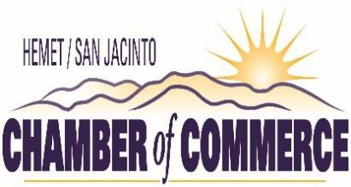

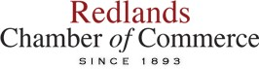
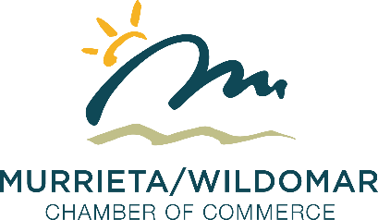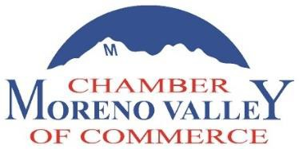

May 25, 2021

The Honorable Lorena Gonzalez California State Assembly
State Capitol, Room 2114 Sacramento, CA 95814

Re: AB 701 (Gonzalez): Warehouse distribution centers – OPPOSE

Dear Assembly Member Gonzalez:

On behalf of the above business organizations in the Inland Empire, we write to express our opposition to your bill, AB 701, which would subject warehouse employers to frivolous litigation based on vague standards and a never-ending presumption of retaliation. It would also prohibit warehouse employers from taking disciplinary action against an employee if performance metrics are not in writing.

AB 701 starts with a false premise – that workplace performance metrics are inherently unsafe and correlated with workplace injuries. All jobs, across all industries, have performance or production measurements to assist the employer in meeting the goals and obligations of the business to customers and business partners. Importantly, an employer who implements a quota that forces employees to flout existing health and safety laws is already in violation of California law.
California already requires all employers to provide a safe workplace, develop and update an Injury and Illness Prevention Program, inspect the workplace to correct any unsafe or hazardous conditions, and much more; warehouse employers are not exempt from such requirements. An

employee who believes their employer is not following these long-established laws may report that violation and already has protections from retaliation for doing so.

AB 701 creates new obligations for employers to provide an array of notices at hiring, as well as on a potentially daily basis related to exact workload expectations and long-term data. If an employer fails to provide these real-time notices, then the employee cannot be disciplined for their performance related to their working speed. Simply put, AB 701’s disclosure requirements are logistically infeasible for many warehouse operations. Performance measures are used to establish planning goals and help create projections for distribution of materials. Some workers may have individualized metrics they try to achieve, some may have metrics assigned to their entire team or their shift, or some may have no metrics at all. The variety here is considerable – making a one- size-fits-all notice requirement infeasible in some cases.

In addition, where metrics are used to monitor productivity, they can also vary significantly depending on the product, facility, time of day, and even a specific workstation (which may change frequently). For example – some workers may switch between tasks or workstations during their shift to help with unanticipated issues or fill gaps related to another worker’s availability. AB 701 would, in these situations, require notice potentially multiple times in a day for a single employee prior to such assistance at another workstation. First, many employers do not have the ability to quickly generate a workflow estimate on a moment-to-moment basis to distribute whenever a worker assists at another station. Moreover, even if the data is readily accessible, the logistics of constantly distributing notices to employees as their shifts or stations change poses another major feasibility challenge.

AB 701 requires Cal/OSHA staff to prepare and to propose a new regulatory standard specific to warehouses by January 2023. AB 701 requires the regulation to be “based on work activity levels”, measurement of production quotas, and safety data. In simple terms – AB 701 is drafted to force Cal/OSHA to define production quotas for warehouse employers, which is unprecedented. Neither Cal/OSHA, nor the Labor Commissioner has ever before been given authority to reach into a workplace and define the rate of work to that degree.

AB 701 includes a host of new requirements and prohibitions for warehouse employers and then relies on a combination of the Labor Code Private Attorneys General Act (PAGA) and a new, independent private right of action to enforce its terms. Threats of litigation mean critical warehouses across our state – transporting food, medical supplies, and household goods – will face litigation based on AB 701’s vague requirements, such as its requirement that performance metrics ensure that workers have time to “comply with all health and safety laws.”

AB 701 includes a presumption of retaliation if an employer takes any adverse action within 90 days of an employee “exercising any right under this part.” This is extremely problematic, since it could create a never-ending presumption of retaliation. For example, under AB 701, an employee is entitled to notice of their performance metrics whenever such metric change (which may be daily). This means an employee could easily voluntarily trigger a never-ending presumption pursuant to Section 2105. If an employee makes such a request every three months – which can be done orally – that employee would have a perpetual presumption that any disciplinary action taken was retaliatory. In the event of serious misconduct and termination, the employer would then be forced to either pay the cost of retaining attorneys to demonstrate that discipline/termination was not retaliatory, and/or to pay to settle any such allegations by the employee. This presumption creates a

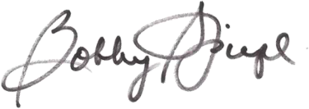
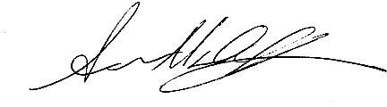
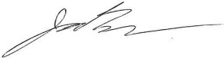
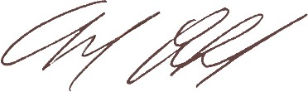
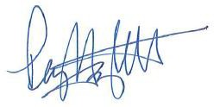
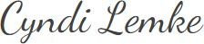
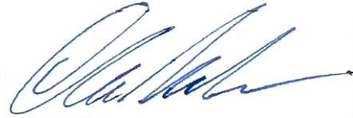
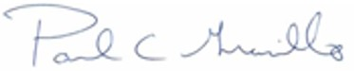
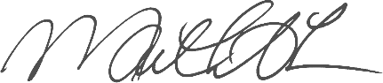
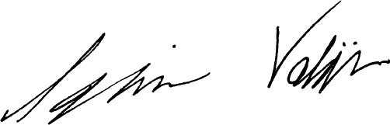
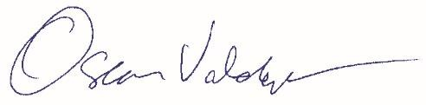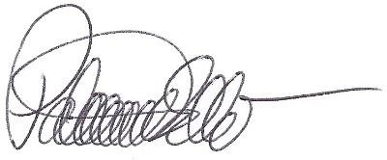constant bargaining chip for the employee to leverage a costly settlement from the employer regardless of whether any actual retaliation occurred.

For these reasons and others, we oppose your bill, AB 701. If you have any questions or would like to discuss our position in greater detail, please contact Luis Portillo at 909-944-2201 or by email at lportillo@ieep.com. Thank you.

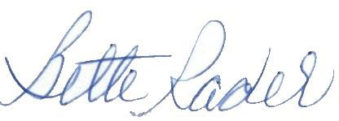
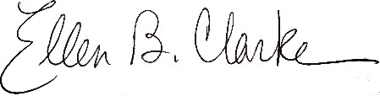
Sincerely,
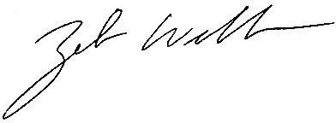
Bette Rader  Beaumont Chamber of Commerce | Ellen B. Clarke  Big Bear Chamber of Commerce | Zeb Welborn  Chino Valley Chamber of Commerce
Bobby Spiegel  Corona Chamber of Commerce | Andrea De Leon  Fontana Chamber of Commerce | Joshua Bonner  Greater Coachella Valley Chamber of Commerce
Mark Creffield  Greater High Desert Chamber of Commerce | Peggi Hazlett  Greater Ontario Business Council | Cyndi Lemke  Hemet San Jacinto Chamber of Commerce
Chris Nielsen  Highland Chamber of Commerce | Paul Granillo  Inland Empire Economic Partnership | Maneesha Jones  Menifee Valley Chamber of Commerce
Oscar Valdepeña  Moreno Valley Chamber of Commerce | Patrick Ellis Murrieta/Wildomar Chamber of Commerce | Ignacio Valdivia  Perris Valley Chamber of Commerce

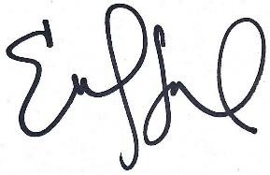
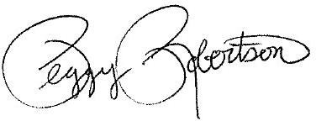
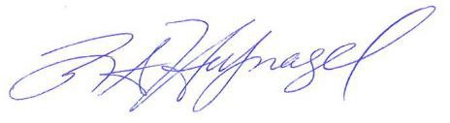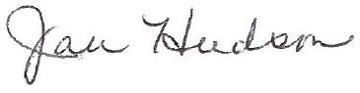
Monique Manzanares  Pomona Chamber of Commerce | Robert Hufnagel  Rancho Cucamonga Chamber of Commerce | Jan Hudson  Redlands Chamber of Commerce
Emily Falappino  Temecula Valley Chamber of Commerce | Peggy Robertson  Upland Chamber of Commerce

